# AMERICAN INTERNATIONAL UNIVERSITY- BANGLADESH

Faculty of Engineering

Laboratory Report Cover Sheet

***Students must complete all details except the faculty use part.***

Experiment Title: Familiarization with an STM32, the study of blink test and implementation of a light- controlling system using microcontrollers.

Experiment Number: 02 Due Date: 06-02-2024 Semester: Spring 24-25 Subject Code: EEE 4103 Subject Name: Microprocessor and Embedded Systems Section: E Course Instructor: Protik Parvez Sheikh Degree Program: BSc CSE

Please submit all reports to your subject supervisor or the office of the concerned faculty.

## Declaration and Statement of Authorship:

1. I/we hold a copy of this report, which can be produced if the original is lost/ damaged.
2. This report is my/our original work and no part of it has been copied from any other student’s work or from any other source except where due acknowledgement is made.
3. No part of this report has been written for me/us by any other person except where such collaboration has been authorized by the lecturer/teacher concerned and is clearly acknowledged in the report.
4. I/we have not previously submitted or currently submitting this work for any other course/unit.
5. This work may be reproduced, communicated, compared and archived for the purpose of detecting plagiarism.
6. I/we give permission for a copy of my/our marked work to be retained by the School for review and comparison, including review by external examiners.

## I/we understand that

1. Plagiarism is the presentation of the work, idea or creation of another person as though it is your own. It is a form of cheating and is a very serious academic offence that may lead to expulsion from the University. Plagiarized material can be drawn from, and presented in, written, graphic and visual form, including electronic data, and oral presentations. Plagiarism occurs when the origin of the material used is not appropriately cited.
2. Enabling plagiarism is the act of assisting or allowing another person to plagiarize or to copy your work



Group Number (if applicable): Individual Submission Group Submission



|  |  |  |  |  |
| --- | --- | --- | --- | --- |
| **No.** | **Student Name** | **Student**  **Number** | **Student**  **Signature** | **Date** |
| **Submitted by:** | | | | |
| **1** | Rifah Sanzida | 22-47154-1 |  |  |
| **Group Members:** | | | | |
| **2** | Md. Joaber Hossain | 22-47116-1 |  |  |
| **3** | Samia Sharmin Dola | 22-47126-1 |  |  |
| **4** | Md. Samin Yeaser | 22-47139-1 |  |  |
| **5** | Shayan Abrar | 22-47156-1 |  |  |



|  |  |
| --- | --- |
| ***For faculty use only:*** | **Total Marks: Marks Obtained:** |
| **Faculty comments** | |

**Title:** Familiarization with an STM32, the study of blink test and implementation of a light-controlling system using microcontrollers.

**Introduction:**

The objective of this experiment is to get familiarized with Microcontroller.

▪ Learning to make the LED blink using ST32.

* Implementation of a light control system using STM32.

**Overview of STM32 Nucleo-F401RE Board:**

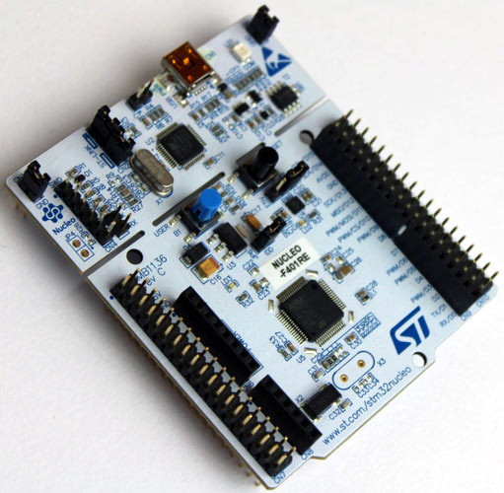

**Pin Configuration:**

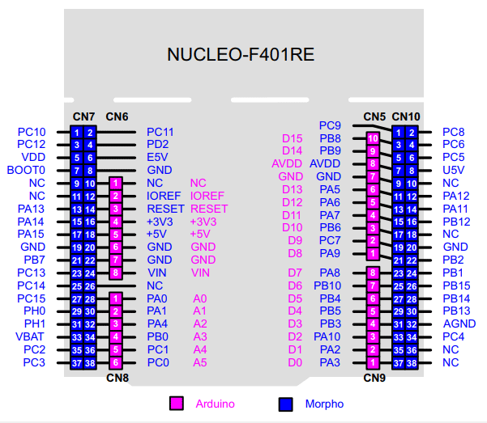

**Pin configuration from STM32Cube IDE:**

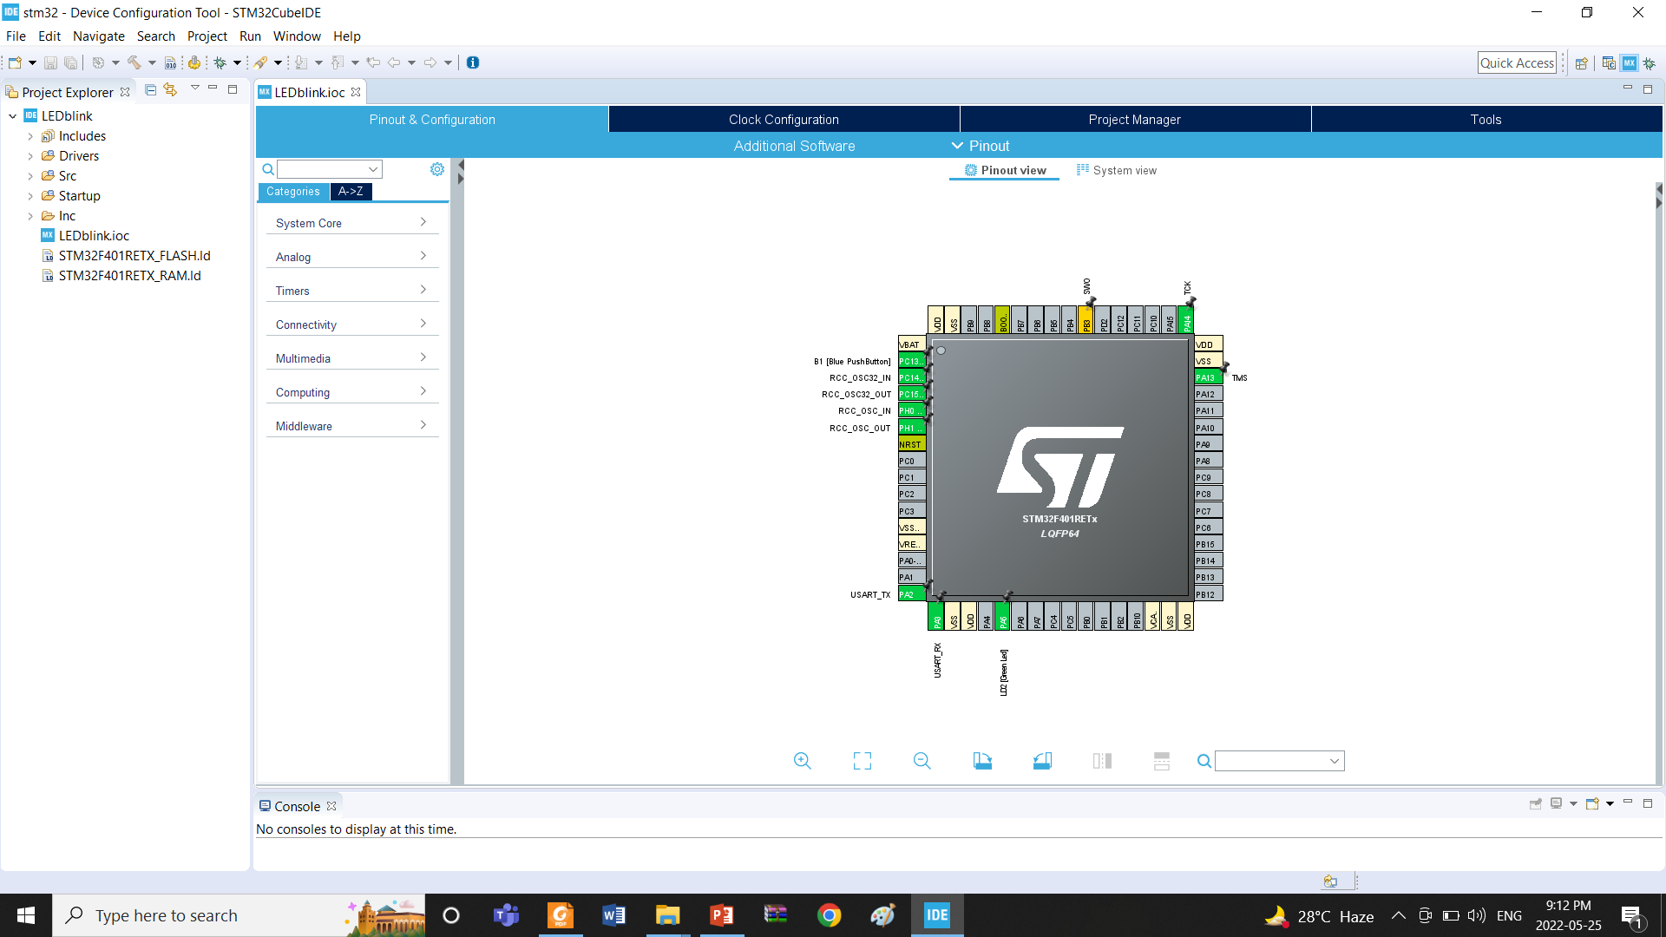

**Apparatus:**

|  |
| --- |
| 1) STM32 Cube IDE (1.0.1 or any recent version) |
| 2) STM32 Cube IDE board |
| 3) LED lights (RED, GREEN, or YELLOW) and three 200 ohms resistors and jumper wires  **Code:**  **(a)Blink LED:**  while(1){  HAL_GPIO_TpgglePin(GPIO,GPTO_PIN_5);  HAL_Delay(1000);  }  **(b)Traffic Light:**  while(1){  #define Red_Pin GPIO_PIN_5 #define Yellow_Pin GPIO_PIN_6 #define Green_Pin GPIO_PIN_7     int red_on = 4000;     int yellow_on = 2000;     int green_on = 4000;     int green_blink = 500;   HAL_GPIO_WritePin(GPIOA,Red_Pin,1);     HAL_Delay(4000);     HAL_GPIO_WritePin(GPIOA,Red_Pin,0);    HAL_GPIO_WritePin(GPIOA,Yellow_Pin,1);     HAL_Delay(2000);     HAL_GPIO_WritePin(GPIOA,Yellow_Pin,0);     HAL_GPIO_WritePin(GPIOA,GPIO_PIN_7,1);     HAL_Delay(4000);     for(int i = 0; i < 3; i++)     {       HAL_GPIO_WritePin(GPIOA,Green_Pin,0);       HAL_Delay(500);       HAL_GPIO_WritePin(GPIOA,Green_Pin,1);       HAL_Delay(500);       HAL_GPIO_WritePin(GPIOA,Green_Pin,0);       HAL_Delay(500);     }     HAL_GPIO_WritePin(GPIOA,Yellow_Pin,1);     HAL_Delay(2000);     HAL_GPIO_WritePin(GPIOA,Yellow_Pin,0);  } |
|  |

**Experimental Setup & Results:**

**Blinking LED:**

|  |  |
| --- | --- |
| **Figure 1**: The Red LED is OFF. | **Figure 2**: The Red LED is ON. |

**Traffic Control System:**

|  |  |
| --- | --- |
| **Figure 3**: The Red LED is ON | **Figure 4**: The Yellow LED is ON |

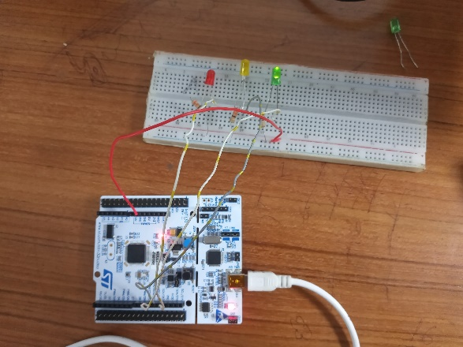

**Figure 5**: The Green LED is ON

**Simulation Setup & Results:**

|  |  |
| --- | --- |
| **Blink Test:** |  |

**Figure 1**: Simulation set-up for blinking test

|  |  |
| --- | --- |
|  |  |

**Figure** **2:** Red LED is ON **Figure** **3:** Yellow LED is ON

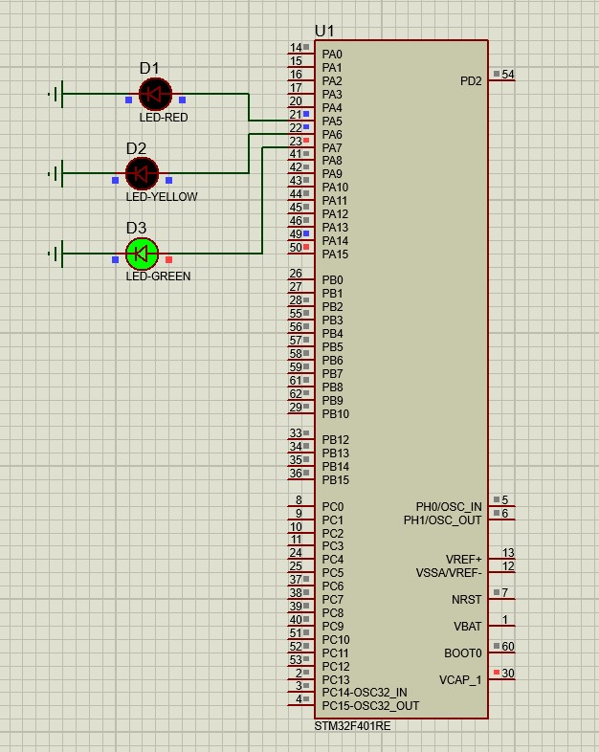

**Figure** **4:** Green LED is on

**Report Questions:**

1. Include all codes and scripts into the lab report following the writing template mentioned in appendix A of Laboratory Sheet Experiment 2

**Answer:** Answer: All code and scripts are attached above.

1. Include the proteus simulation of the blink program and light control system.

**Answer:** All things are attached above.

1. Design a simulation for a traffic system using the Proteus simulation tool and STM32Cube IDE.

**Answer:** All things are attached above.

**Discussion & Conclusion:**

The project was completed flawlessly, as was indicated in the outcomes section. The Red LED was turned on for 3 seconds as the initial stage to aid in traffic management. Eventually, the Red Light turned off. The Yellow LED suddenly turned on, glowed for 3 seconds, and then turned off. After that, the Green LED was turned on and lit for 2 seconds and blinked for 3 times. The Yellow LED then turned on for 1 second. The process was then repeated with the Red LED turning on this time, after which all LEDs were turned off. This pattern continued without change.

In this experiment's goals were to get to know the STM32, investigate the blink test, and build light control with a microcontroller. The STM32 microcontroller was debugged using STM32CubeIDE, which was also used to create the system's tests and numerous pieces of code. The STM32 Nucleo-F401RE board's pins were attached to the breadboard successfully. The circuit board that held all the LEDs was wired to replicate the appearance of the original traffic light on the street. I then attached an LED to an STM32 microcontroller that was integrated into the circuit board. Only PA5, PA6, and PA7 of the several pins of STM32 microcontrollers are connected to LEDs. I then used a USB cable to connect the microcontroller to my computer and gave the system program instructions. In the command code, a while loop was employed. The LED's output functions properly and produces the desired outcome. The experiment was successful all around.

**Reference(s):**

* <https://www.st.com/en/evaluation-tools/nucleo-f401re.html> for STM32F401RE, datasheet
* [www.st.com](http://www.st.com/)
* <https://www.st.com/resource/en/user_manual/dm00105879-description-of-stm32f4-hal-and-ll-drivers-stmicroelectronics.pdf>
* [www.st.com/en/development-tools/stm32cubeide.html](http://www.st.com/en/development-tools/stm32cubeide.html)